

## Topic: Logging Into and Out of theSource

You may experience instances when you’ll need to know how to manually log into and out of theSource - keep reading to find out why and how.

**Logging In**

You may need to manually log into theSource when Single Sign On (SSO) isn’t available - the below instructions will get you in!

1. Open **Google Chrome**.
2. Access **theSource**: <https://thesource.cvshealth.com/nuxeo/thesource> (You can bookmark this page!)
3. Enter your Network ID and Password on the Login page.

**Note:** If you have already logged into LearningHub, the P&P Portal, Workday or ColleagueZone, you may be able to access theSource without re-entering your login credentials.

**Logging Out**

There may be times during training or when experiencing system issues where you’re asked to log out of theSource. To log out:

1. Click the **Profile** icon (located in the upper right of the screen).



1. Click **Logout**.

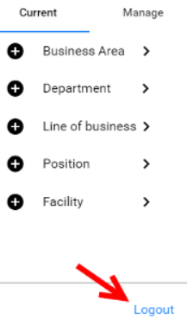

**Notes:**

* If you are having issues with theSource, close the Google Chrome window, re-open, and try your action again.
* For security purposes, theSource will automatically log you out if you have been inactive for 10 hours. To log back in, simply click the provided hyperlink to return to the log in screen:

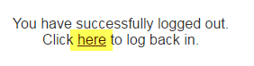

 Your next challenge on the quest to becoming a Certified theSource Wizard is to practice manually logging in and logging out of theSource.

Additional resources:

Become a Certified theSource Wizard: Index

Not to Be Reproduced or Disclosed to Others without Prior Written Approval

**ELECTRONIC DATA = OFFICIAL VERSION / PAPER COPY = INFORMATIONAL ONLY**